**Certificate of Membership**

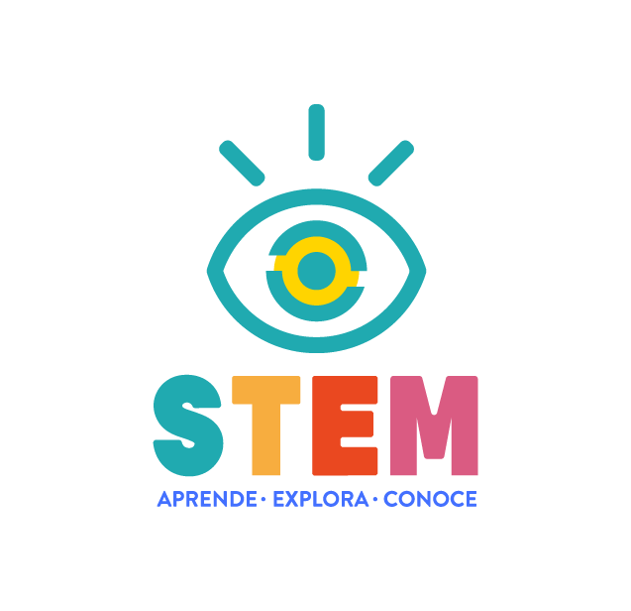

This certificate is awarded to

**Mr. Estefano Muñoz Moya**

For his continuous contribution to children's learning in basic science.

Silvana Vega Yañez